**Home**

1. Banner 1 Standard

2. Banner 2 Workshop

3. Courses

* Master
* Diploma
* Short Term

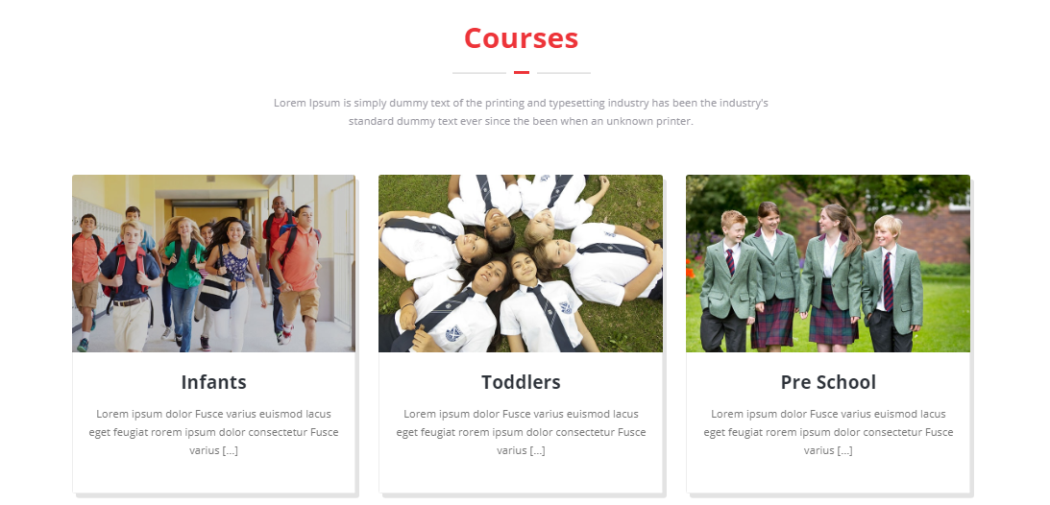

4. About Istrategist (With Button to About Us page)



5. Upcoming webinar (Date format) (With link to Webinar page)

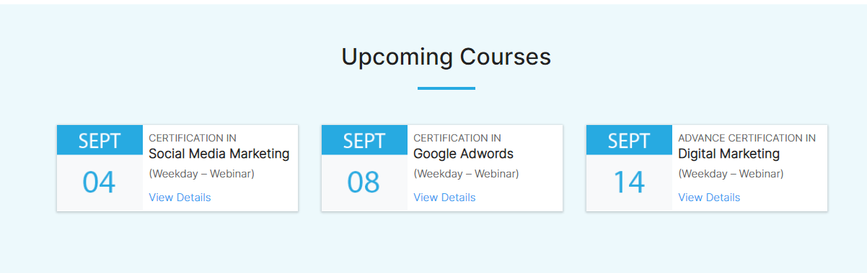

6. Placement Partners

100% placement assistance

7. Blog (Link to blog page)

8. Footer

**About Us**

1. Image (Full breadth banner)

2. Who are we? (Vision line to be added)

3. Awesome Services

* Live Session
* Class-room training
* Workshop
* Corporate Training
* Career counseling
* Support Centre

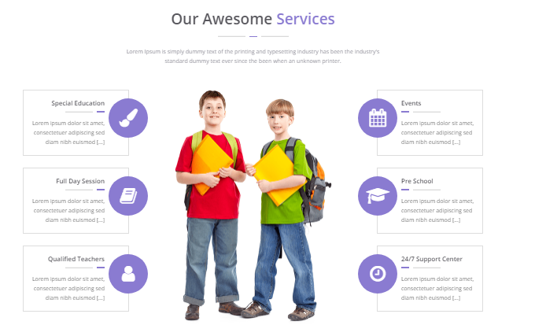

4. 5 reasons

* SPR module of Training
* ISO Registered
* 100% Job assistance
* Learn from industry expert
* Career oriented program

5. Want to learn? (With link to courses page)



6. Numbers

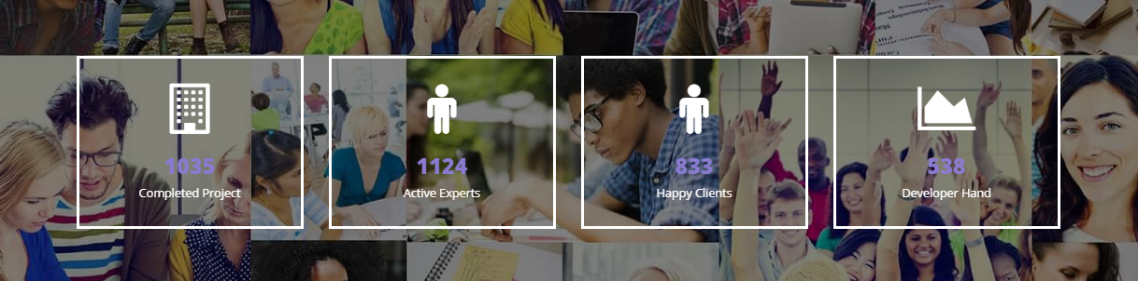

7. Trainers

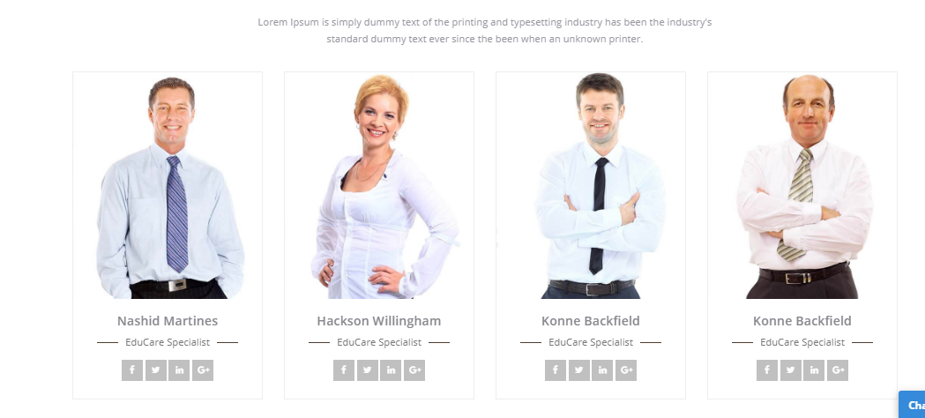

8. Footer

**Programs & Courses**

**Master**

1.Headlines with Mnemonic representation of course

5 modules, 2 months, 100 min assignment, 1 internship, Certification, 7 New Tools

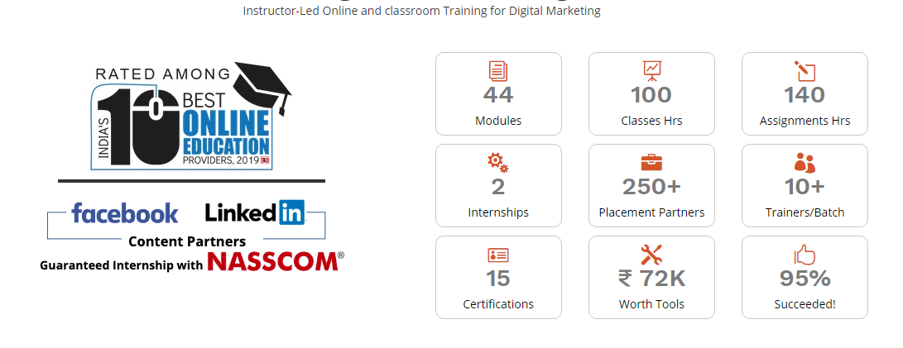

2. Who is it for?

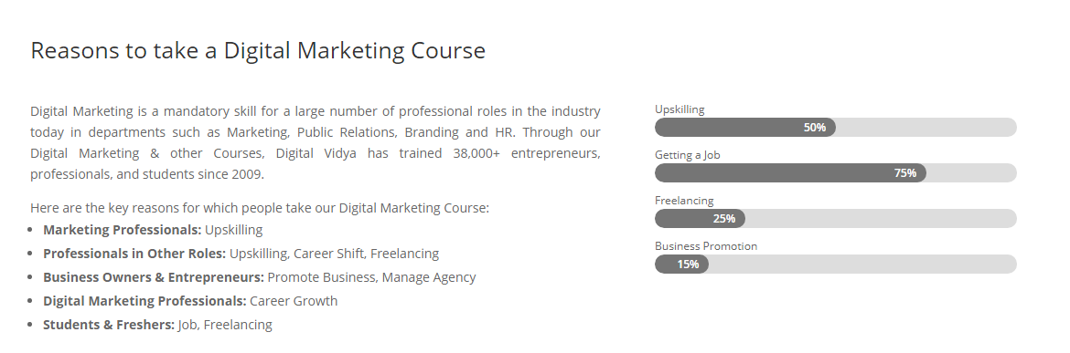

3. Course Curriculum

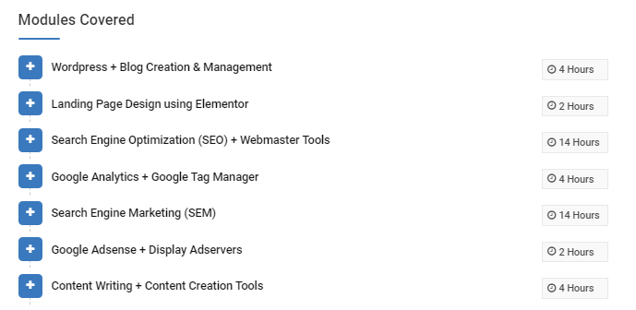

4. Download button for Course Module

5. Tools you will master

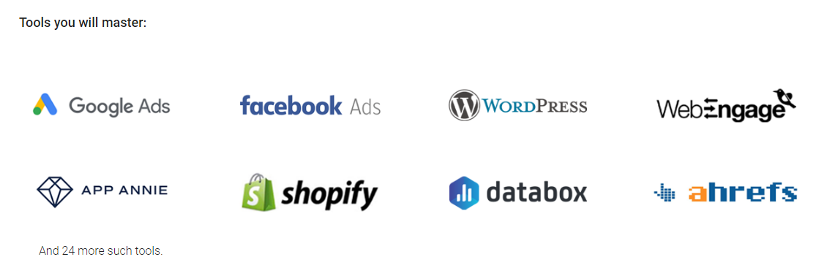6. Admission process, eligibility and fees

7. Career prospect

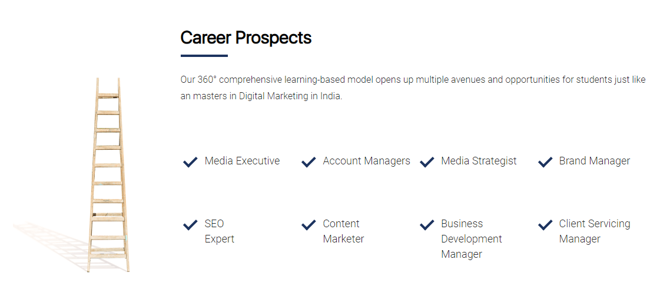

8. Book a call with our counselor (Free)

9.. FAQs

10. Footer